Survive and Thrive: Preparing Your Business for Funding Presesnter and Panelists

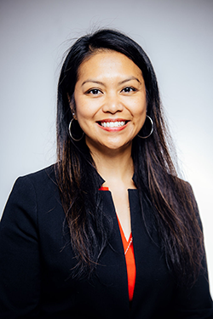

Abigail Scanlan, Women’s Business Development Center, Director of Access to Capital
Abigail Scanlan serves as the Director of Access to Capital for the WBDC. She assists her clients in navigating the complexities of obtaining appropriate funding for their businesses as well as in escalating and growing their businesses through additional capital and financing. After working in the banking industry for many years, Abby brings her enthusiasm for advising entrepreneurs and helping them succeed to the organization. She has partnered with a wide range of businesses from startups to established enterprises, providing financial guidance and strong banking partnerships.

Website: https://www.wbdc.org/about-us/team/

Contact- sign up to the business advising sessions at cookcountysmallbiz.org

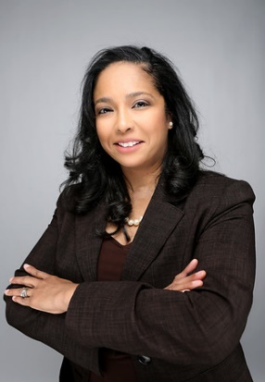

Valicienne Arnold, Arnold, Knox, LLC - CPA/ Chief Financial Officer

Val Arnold is the found and owner of Accounting Firm, Arnold Knox, LLC. She guides clients through a full range of tax planning and preparation, while providing accurate and insightful financial information in order to maintain profitability. She focuses on building close client relationships that add long-term value, her assurance services will improve information quality or its context, meaning more success for your business.

Website: https://www.arnoldknox.com/

Contact information: varnold@arnoldknox.com

Matt Quinn, Illinois Restaurant Association, Assistant Director of Government Relations & Communications

He is responsible for monitoring legislation and regulations that impact the restaurant and hospitality industry, disseminating this information to IRA members, and advocating on behalf of the association. Matt also directs the IRA’s efforts to present the Association’s programs, accomplishments, and policy positions to its members, government officials, and the public.

Before working at the IRA, Matt worked for several elected officials in the Illinois House of Representatives and the Democratic Party of Illinois. He earned his Bachelor of Arts degrees in Political Science and History from the University of Illinois at Urbana-Champaign in 2012.

Website: https://www.illinoisrestaurants.org/

Contact: mquinn@illinoisrestaurants.org Sign up to the business advising sessions at cookcountysmallbiz.org

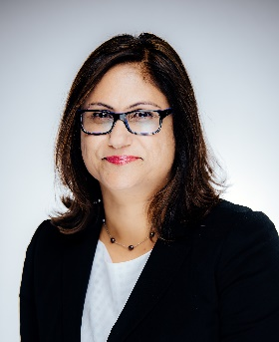
Lotika Pai, Women’s Business Development Center, Managing Director, Access to Capital,
Lotika Pai is the Managing Director of Access to Capital at the Women’s Business Development Center. She works with both start-up and established business owners helping them with their capital goals. She understands that access to capital is critical for small business success, especially for those in underserved markets, including women, minorities, and low to moderate income communities. She manages the growth of the WBDC direct loan fund and building the organization’s capacity to interact with clients seeking access to capital, as well as leveraging partnerships with traditional and non-traditional financial institutions to better serve the business owners we work with.
Lotika brings a diverse range of professional experiences to her role. She is a successful entrepreneur, and a former Investment Banker at Lehman Brothers and Barclays Capital.

Website: https://www.wbdc.org/about-us/team/

Contact- sign up to the business advising sessions at cookcountysmallbiz.org

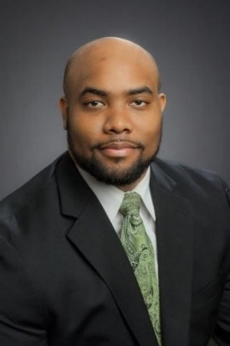

William J. McIntosh III , The Chicago TREND, Director of Real Estate Finance and Small Business Services

William is the Director of Real Estate Finance and Small Business Services for The Chicago TREND Corporation. He joined the organization in November 2020 after working as a corporate banker with PNC Financial Services Inc. for seven years. In his role at TREND, William supports real estate development and economic development opportunities, while providing financial acumen and market knowledge, as TREND engages with diverse business owners across the Chicagoland area. William graduated from Florida Agricultural & Mechanical University (FAMU) in Tallahassee, FL with his Master’s in Business Administration, with a focus on Finance & Accounting, from the institution’s accelerated Professional M.B.A program.

Website: http://www.chicagotrend.com/

Contact- sign up to the business advising sessions at cookcountysmallbiz.org

