Survive and Thrive: Preparing Your Business for Funding Presesnter and Panelists

Ana Paula Ballesteros, Illinois Hispanic Chamber of Commerce, Business Advisor
Ana Paula Ballesteros serves as a business advisor at the Cook County COVID-19 Recovery: Small Business Assistance Program. As a U.S. Hispanic advertising expert, Ana Paula is a young Sales and marketing professional in the US Hispanic markets.She graduated from the University of Houston with a major degree in Corporate Communications and a master’s in corporate sales. Today, she has 10 years of experience helping small and global companies grow in the US Hispanic market and reach Latino audiences across different digital touchpoints.

Website: https://ihccbusiness.net

Contact- sign up to the business advising sessions at cookcountysmallbiz.org

Iliana Tostado, Illinois Hispanic Chamber of Commerce, Business Advisor for Cook County COVID-19 Recovery: Small Business Assistance Program​

Iliana has always been passionate about helping businesses grow. And as a Business Advisor for the Illinois Small Business Development Center at the Illinois Hispanic Chamber of Commerce she knows she is doing just that by providing advice to those businesses in need. Iliana formed Accent Marketing, Inc in 1997 with the goal of serving advertisers reaching out to the Hispanic market. As President she expanded the business to include a full range of advertising and marketing services including creative, media buying, social media and promotions to a broad mix of corporate clients.

Iliana holds a BA in Communications from UCSD and an MBA from Loyola Quinlan School of Business. She specialized in marketing and received a certificate in electronic commerce. Iliana has served as an adjunct faculty instructor at Columbia College in the Marketing Department and has taught courses in marketing and advertising.

Iliana's commitment to her clients and the community has provided the impetus for various community projects, such as El Aventon -- a free shuttle bus in Chicago's Little Village. In 2005 she co-founded The Chicago Latino Network, a publication targeting professional acculturated Latinos. She was instrumental in the founding of the St. Jude Hispanic Professional Advisory Council in 2006 and served on the council from 2006-2014. She is currently a mentor for YEA the Young Entrepreneur Academy.

Website: https://ihccbusiness.net

Contact- sign up to the business advising sessions at cookcountysmallbiz.org

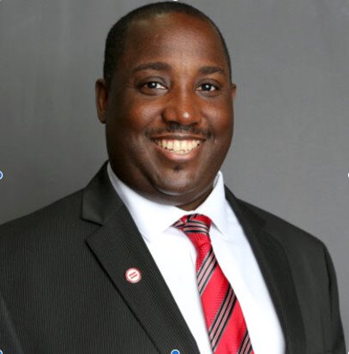

Leslie Williams, Chicago Urban League, Technology and innovation Program Manager

Leslie Williams is the Technology and Innovation Program Manager at the Chicago urban League. He has over 15 years of experience in the IT industry serving as a System Administrator, Tech Support Specialist and Consultant.

Website: https://chiul.org/programs/

Contact: Sign up to the business advising sessions at cookcountysmallbiz.org

Tameka Grant, Sassy Thrifters, Owner and Founder

She’s the designer at Sassyriez, Brand Ambassador for Hand Candy Couture, BRIJ Stakeholder, fashion blogger, foodie, world traveler, thrift enthusiast and creator of SassyThrifters, a platform where thrifters unite! The social media group started with “Thrifting in Chicago” bus tours and since then, has evolved into doing community events such as Fleek Market/Rummage sales, food drives, coat drives, free make-overs for well deserved Moms, health & wellness, book clubs, travel, quarterly DIY workshops and so much more!

Website: https://www.sassythrifters.com/shop

Contact- SassyThrifters@gmail.com

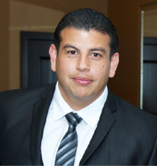

Fernando Velasquez , Launch 35, Founder

When you help other people, they help other people, and then at some point, they help you in return. Fernando built LAUNCH35 with this mindset.

The first time Fernando tried starting a business for basketball tournaments, he spent over $4K on a site that took way too long to go live and still had many glitches.

He wasted a lot of time, energy, and money. From then on, Fernando learned how to build websites on his own, and now Fernando ensures other aspiring entrepreneurs don’t have the same frustrating experience when building their site.

Fernando earned his B.A. in Social Sciences, emphasis in Economics, and minor in Cinematic Arts from the University of Southern California.

Website: https://www.launch35.com

Contact- https://www.linkedin.com/in/fernando-velasquez/

